ACAO Board of Directors Meeting
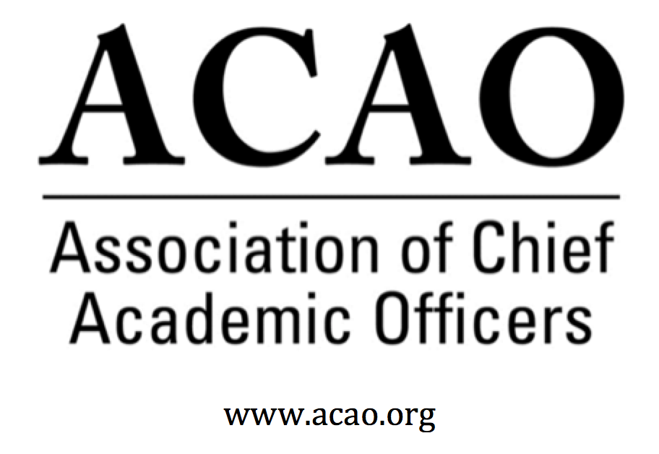

Minutes

November 7, 2018, Conference Call

Name | Attend | Name | Attend | Name | Attend
Martha Potvin | Yes | Laura de Abruna | Yes | BJ Reed | Yes
Kathy Johnson | Yes | Peter Nwosu | No
Mary Boyd | Yes | Gregory Ochoa | Yes
Rick Miranda | No | Patricia Rogers | Yes
Kevin Carman | Yes | Michaela Whelan | Yes
Charles Cook | No | Connie Johnson | Yes | Doreen Murner | Yes
Kelli Brown | Yes | Todd Diacon | No

- October 3 Board Minutes – Vote to approve – M. Potvin
  - Mary Boyd motioned to approve; BJ second – All in favor
- ACE/ACAO MOU Update: M. Potvin/K. Johnson – Martha & Kathy drafted 1st version to send to ACE. Most of the contact has been with Nicole Woods (not Louis or Philip). Will ACE allow access to the Engage Platform without cost to ACAO? Discussion: ACE sees this as a primary revenue component.
Board agreed to define future sponsorship with ACE to be $5000 for the Breakfast & Business Meeting.
For the 2019 booth activity, board wants the measure of new members coming directly from that outreach.

  - FYI: ACAO investment in ACE
1. ACE annual dues paid by ACAO.
Member type: Non-institutional national organization
Dues: $3328

2. ACE Exhibit Booth @ Annual Meeting
10x10 booth
Fee: $2300

3. ACE Sponsorship for ACAO Business Mtg & Breakfast
Fee: $7500
Total: $13,128
- Strategic Plan Update – K. Johnson – The Strategic Plan went from a sparse plan to a newly refreshed version, with re-structuring goals & objectives. Each committee chair and member should look at the plan & see where the committee aligns with the plan on the goals & objectives. Please take a look at the objectives and see where it makes sense to fill in specific details. We want this completed before our meeting in January so we can move the strategic plan forward.
Committee chairs/members to look at the plan via the below link. Align the committee’s goals with the appropriate SP goals.
https://docs.google.com/document/d/1qIs5kmCx8Lybmnd-3MZhYPI1Yax20hQ4o7x3oUgvaEk/edit?usp=sharing

- Membership Committee Update – G. Ochoa – Much discussion on membership and lapsed members. Michaele suggested alternative rates for international members, since we have global reach. Also discussed was a tiered dues structure for “system” memberships. Ex: If all campus provosts become members, dues will be discounted 20% or give each campus provost a 20%-33% discount for their first year. And, questions raised about system academic leaders as members and all agreed better to keep our target to provosts/CAOs. Membership committee will look at all the dues discussions and make recommendations.

- Communications Committee Update – C. Johnson Web site is being updated. ACAO has two Facebook accounts, recommendation was to move to one due to confusion on which one was for what purpose. Communication committee wants to work with the membership committee.

- Bylaws Committee Update – R. Miranda No update
- Finance Committee Update - M. Boyd – Mary went first on the agenda due to importance of discussion. As of Sept, ACAO is approx. $30k in the red. 89 paid renewals, about 100 non-renewals. Must address shortfall needing about 60 members @ $500 ea. dues. Ideas to consider: Post marketing on CIC listserv about ACAO. Membership flyers needed for the ACAO regional digital fellow meetings. Roster of provosts at CIC schools and reach out to them.
Doreen will provide institutional names & contact info on those who have not renewed to the board. And work with G. Ochoa to set up a membership committee meeting.

- Nominating Committee Update – BJ Reed There are a potential of 5 provosts who have showed interest in running for the board. Institutional diversity is also being looked at. Question about board protocol on rolling off the board to keep continuity on the committees. All current board directors attend the January meeting. New board members are presented at the Business Meeting in March. Current directors can be considered for another term. Ballots will go out early Jan/Feb 2019, 6 weeks before the ACE meeting.

- Advisory Council Update – C. Johnson Coffee hrs. have low attendance to date but great conversations. Ask A Provost has had no requests to date. Suggestion was to use AAP as a recruitment tool. Membership committee will look at that too.

- Winter Retreat: Jan 25, 2019, Washington, DC @ ACE

Future Board Meetings

Dec 5, 2018 2:00pm ET
Jan 2, 2019 2:00pm ET
Feb 6, 2019 2:00pm ET
Mar 6, 2019 2:00pm ET

