ACAO Board of Directors Meeting
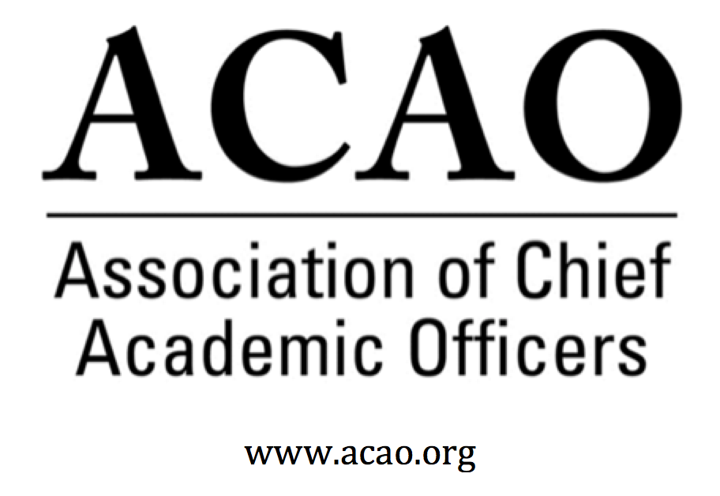

Minutes

December 12, 2018

Name | Attend | Name | Attend | Name | Attend
Martha Potvin | Yes | Laura de Abruna | No | Michaele Whelan | Yes
Kathy Johnson | Yes | Peter Nwosu | Yes
Mary Boyd | Yes | Gregory Ochoa | Yes
Rick Miranda | No | Patricia Rogers | Yes
Kevin Carman | No | Connie Johnson | No
Charles Cook | No | Todd Diacon | Yes | Doreen Murner | Yes
Kelli Brown | No | BJ Reed | Yes

- Nov 7 Board Minutes – Vote to approve – M. Potvin
  - BJ Motioned to approve 11/7 minutes. Pat 2nd. All in favor, motion passes.

- CCAS Opportunity – M. Potvin Discussions were held with the Council of Colleges of Arts & Sciences for opportunities to partner, especially in workshops and other educational formats surrounding a tool kit for deans. Looking for a potential session for deans on relationships with provosts.

- ACE/ACAO MOU Update: M. Potvin/K. Johnson Discussions continued with ACE and updated MOU presented. Both Kathy & Martha are comfortable with the agreement. Due to ACE’s reorganization and re-envisioning, they can’t commit to an agreement for more than 1 yr. Sponsorship fee is now at $5000 (v. $7500).
  - Motion to approve MOU. BJ 1st, Greg 2nd. All in favor. Motion passes.

- ACE New Provost Institute – M. Potvin/K. Johnson Continuing discussions on ACE New Provost Institute, which may be an opportunity for ACAO if ACE doesn’t continue with the Institute. AASCU also has a Provost Leadership Academy & should we consider a partnership there? Or maybe CIC? Move discussion to January meeting.

- Strategic Plan Reminder – K. Johnson
Committee chairs/members to look at the plan via the below link. Align the committee’s goals with the appropriate SP goals.
https://docs.google.com/document/d/1qIs5kmCx8Lybmnd-3MZhYPI1Yax20hQ4o7x3oUgvaEk/edit?usp=sharing

Reminder for everyone to look at the Strategic Plan and be prepared to discuss at our January meeting.

- Membership Committee Update – G. Ochoa Membership Committee sent a survey to 370 members and non-members. To date only 20 responses. All agreed to resend at the beginning of the year to garner more results. Reminder to update the lapsed member roster that was previously sent out. Concerns with the wording on the web site for “system” membership. System definition needs to be stated more clearly on the web site. Ex: System Office membership does not include the campus. Each campus is a separate fee from the system fee. UMaine wanted all 7 campuses to be under the system membership and to include the system CAOs. We don’t want to lose them as a potential member so options: 1. 33% off (as discussed in a prior meeting) #2 honor the system fee for this year to include the campuses but let them know it will be different next year.

- Communications Committee Update – C. Johnson Committee wants to continue to work with Membership. Next membership Cmte meeting will include Communications Cmte.

- Bylaws Committee Update – R. Miranda No report

- Finance Committee Update - M. Boyd Bottom line is unchanged from last month. We still need to increase membership since it is our only revenue source. BJ encouraged board to use Facebook.

- Nominating Committee Update – BJ Reed Draft slate presented to the board. It will be finalized at the January meeting then ballots will be sent out.

- Advisory Council Update – Coffee Hr./Ask A Provost – C. Johnson Advisory Council is considering recording the first 30 minutes of each Coffee Hr. which will provide additional resources on our web site for provosts. The open Q&A 30 minutes will not be recorded.

- Jan 2 board meeting date?? Meeting has been cancelled

- Winter Retreat: Jan 25, 2019, Washington, DC @ ACE
Schedule:
Arrive 1/24. For those that are available, casual dinner 6pm ish. Restaurant TBD.
1/25: 8-9am Continental Bkfst @ ACE office. 9-3pm ACAO Board Meeting @ ACE.

Future Board Meetings

Feb 6, 2019 2:00pm ET
Mar 6, 2019 2:00pm ET
March face to face @ ACE Annual Meeting

