ACAO Meeting Minutes
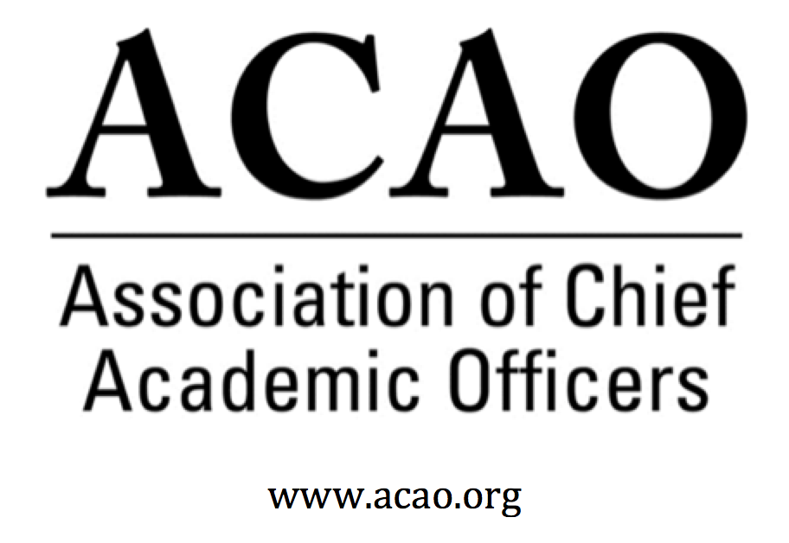

July 26, 2018

Seattle, WA

Attendance/Roll call:

Name | Attend | Name | Attend | Name | Attend
Martha Potvin | Y | Laura de Abruna | Y | Michaele Whelan | N
Kathy Johnson | Y | Peter Nwosu | Y | BJ Reed | Y
Mary Boyd | Y | Gregory Ochoa | Y
Rick Miranda | Y | Patricia Rogers | Y
Kevin Carman | Y | Beth Ingram | N
Charles Cook | Y | Connie Johnson | Y | Doreen Murner | Y
Kelli Brown | Y | Todd Diacon | Y | Sherri Lind Hughes | N

- Digital Fellows Convening – updates and future grant opportunities - L. de Abruna & C. Green
  - 35 attended the DF Convening. Project deadline has been extended to September 30, 2018. Approval for dissemination to April 2019.
  - ACAO continues to be involved with Digital Fellows until 2015, long term. Is there another organization we can pair with and are there other funders? Suggestion: Laura to organize a sub-set of the board, a special interest group, to keep the momentum of DF moving forward. New committee will be added to the ACAO committee roster.
  - BJ – critical to the project is a DF web portal for the 30+ schools to communicate in an efficient way and for the public to find out about the DF program. Two sites: one for DF only and one for the general public. ACAO private site; ACAO public site. DF would be in both or have their own web site with a link to ACAO. BJ and Casey will explore.
  - Peter suggested a book to collect all the DF case studies with a meta-analysis from Casey. Digital Fellows write a report on their projects then ACAO gets permission to add to the book compilation for dissemination. Suggestion for a second digitals fellows project creating revenue for ACAO. ACAO would own the space in this arena. Mode: AACU Institute on Globalization or ACE Fellows Program. Bring together a campus team of faculty, instructional designers and provosts. ACAO needs to stake its claim in Digital Learning. The new “Digital Fellows” committee chaired by Laura will look at these ideas. All agreed this was a great marketing opportunity for ACAO to have a known recognized branded program.
- ACE/ACAO Teleconference (approximately 9:30/10:00 am start) – This wasn’t able to happen.
- June 6 Board Minutes – Vote to approve – M. Potvin
- Committee Updates and Reports – Committee Chairs:
  - Nominating - BJ Reed: There are 3 open board seats. There were 4 individuals who expressed interest in serving on the board. Discussion on filling the unexpired terms of the vacant seats ASAP or wait for elections. Discussed adding a “Member at Large” to maintain capacity on the board. BJ will create a matrix for institutional diversity for the board: Size, Geography, Type, Gender
  - Communications – C. Johnson: ACAO has two Facebook pages. Initially one was considered to be “for members only” to ask delicate questions and the second was the public facing page. However, there was discussion on general provost hesitancy to post anything on any media platform (twitter, Facebook, listserv) that would expose campus or president. How to create a “safe space” dialog forum for CAOs? Consider the outcome first: Do we want to market ACAO or create “internal discussion space”? All agreed they want to connect with like minded members to ask specific questions, to create the opportunity to network with other provosts. Ex: CIC listserv
  - Connie: wants to create a subcommittee or focus group to help improve communications proactively. ACAO updates would be added to the communications. Facebook metrics would be analyzed. Charles Cook would like to be on the Communication Cmte. Connie will converse with Membership Cmte for ideas too.
  - Annual Mtg Program - K. Johnson: Discussed history of annual meeting at ACE conference. Conversations focused on Educause who may want to partner in the Digital Learning space, bringing together student success and academic technology. There is a whole arm of Educause (ELI) working on academics. Educause is one of 13 members of the Digital Solutions Network.
  - Peter: ACAO is a new organization trying to find differentiation in a crowded market, maturity level isn’t yet developed. What’s so compelling about ACAO? What do we have to offer?
    - Professional Development: mentoring, coaching for aspiring provosts
    - Relationships with other groups/expanding to other groups where provosts belong
    - Student success arena focusing on Digital Fellow learning.
  - Bylaws – Rick Miranda discussed “system membership”. Laura will join the bylaw committee.
  - Finance – Mary Boyd: Discussion of ACAO financials. DF “unapproved older budget” will be removed and only approved current budget will be presented going forward. Look to create monthly dues & membership reports. Doreen & Mary will meet after the board meeting.
  - Membership – Chair replacement discussion: New membership chair: Greg Ochoa and Rick Miranda.
- Membership acquisition ACAO Strategic Plan – status and updates and assignments – M. Potvin: What are we going to focus on for the next three years? – Communication needs a strategy. Refine & develop sharper focus on specific themes within the strategic plan. Revisit SP as a living document. Goal: to submit a revised document in October for Jan board meeting & ready to go for March face to face meeting.
  - Strategic Plan discussed. K Johnson will update SP to reflect and address current discussions. Drill into the SP for more relevant concerns for members. ACAO value proposition discussed. How do we benefit members? Create a more sophisticated document.
  - Board wants to work with Casey for help in ACAO web design and appropriate architecture.
- Advisory Council updates – C. Johnson: Webinar attendance on the whole was light and not as expected. Marketing and timing both need to be worked on. Suggestion to Adv Council: hold webinars Sept – Apr only (maybe not December). And, overbook the event. Allow many to register figuring the non-show of so many who do register. Board members to look for newly publicized provost content that fits the “fireside chat” concept of the webinars and feed to the Advisory Council. Don’t want to rely on retired provosts to do all of the webinar content.
  - Ask A Provost program
    - Accompanying Guidelines
  - Recommended comments from attorney
  - Future Coffee Hr. topics from board/membership. What does the board want to see?
  - 2018/2019 Advisory Council Responsibilities
    - Motion: to accept Ask a Provost program as described as a formal ACAO program. Laura 1st: Rick 2nd: All in favor – passed unanimously
    - Measurements: categories of questions (drop down box of question themes) and number of requests/months.
- ACAO and ACE Relationship and Opportunities – M. Potvin: ACAO sees ACE as a key partner. ACE apologized for dropping the ball with ACAO. The best partnerships move from transactional to strategic. ACE is changing – new strategic framework to members. Having a consistent relationship has been a challenge with ACE turnover. ACE new venture is on line learning for leadership development. ACAO can be helpful with this strategy. ACE is promoting higher ed leadership excellence. They create and curate content. Can ACAO & ACE share content? ACE is working with NADOHE and others. ACE call for programs is early August. ACAO wants to have a collaborative process for designing CAO content. Looking for at least 2 sessions with CAO interests and a continuation of the Master Class concept.
  - Questions:
    - How is ACAO part of the new strategy? And what does it mean?
    - If there are provost sessions at ACE, ACAO needs to be involved with content and presenter selection.
    - ACAO wants input into the CAO Institute and branded marketing to ACAO (recognition).
  - MOU has to be worked on by the next meeting. Kelli Brown will work on it. Who will attend Sept 5th conf call with ACE? To what extent is ACE co-extensive with ACAO? Digital platform to deliver leadership content and create community is changing the delivery of content. ACAO has the ability to offer content and presenters on academic issues – Provost perceptions on academic issues. This standing offer needs to be very clear in MOU.
  - NADOHE and their ACE relationship – how does it work – what can we learn:
- New Business
  - Winter Retreat Location & Dates: suggestion – meeting in DC at ACE building. Invite ACE staff to lunch to create relationships. This is who we are.
  - New Committee: Digital Fellows Cmte: Laura will create charges relating to dissemination, outreach and other collaborative opportunities.
  - Sponsorship revenue opportunity to sponsor programming: Search firm industry is a target.
- Executive Session
Future Board Meetings

Aug 1, 2018 2:00 PM (ask Board) Meeting will be cancelled.
Sep 5, 2018 2:00 PM
Oct 3, 2018 2:00 PM

Meeting and Hotel Information:

The Maxwell Hotel Downtown – for more hotel information, click the url below
300 Roy Street
Seattle, WA 98109
206-286-0629
https://www.staypineapple.com/the-maxwell-hotel-seattle-wa

Room Reservations:
The ACAO Board has a reserved block of rooms July 25 – July 27 (2 nights).
For those of you who are also Digital Fellows, they have a separate block beginning July 23. The DF program will reimburse your DF room nights. ACAO does not reimburse for the board meeting (July 25-July 27).

For the ACAO Board Meeting group, guests have until Monday June 25th to create their reservations by calling in or creating reservations online. Guest will be using the Booking Code: ACAO2018

In order for guests to book online with that code, they just need to follow the directions below.

Please note that the online booking code and link will only work for contracted room nights.
· Visit: https://www.staypineapple.com/
· Click "Our Hotels"
· Select Hotel
· Scroll down to "Rooms"
· Click "Book Now"
· Enter dates of stay
o Special Codes > Enter Group Code: ACAO2018
· Click "Check Availability"
· Select room type and complete booking form

If a guest would like to come in early or stay a day later then they will need to make their reservation by calling our reservations department at 866-866-7977 or emailing them at reservations@staypineapple.com
Ground Transportation:

The Maxwell does not have a hotel shuttle. You will have to take a taxi or you can use Uber/Lyft. They pick up at the garage where the taxis are. The hotel is approximately 17 miles from the Seattle Airport.

