ACAO Board of Directors Meeting Minutes
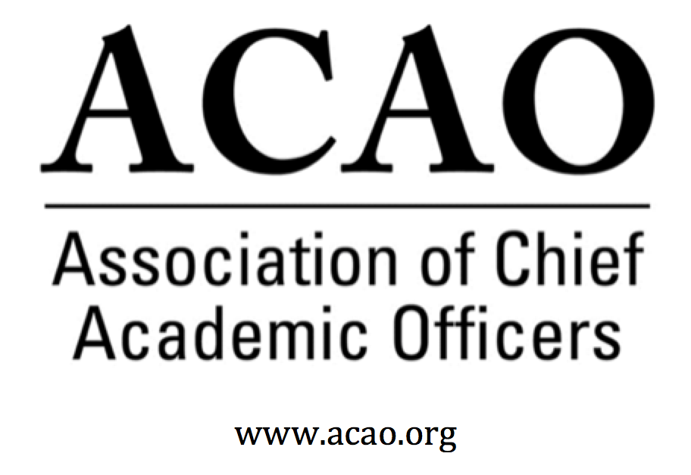

September 9, 2020: https://zoom.us/j/707742741, 2-3 PM (Eastern)

Name | Attend | Name | Attend | Invited Guests | Attend
Mary Boyd |  | Pam Stinson | x | Junius Gonzales
Gail Baker |  | Greg Ochoa |  | John McCarthy
Kathy Johnson | x | Peter Nwosu |  | Michael Quillen
Beth Ingram | x | Patricia Salkin
Scott Newman | x | Andrew Shean | x
Laura de Abruna |  | Constance St Germain
Michael Evans |  | Lori Werth
Connie Johnson | x | Laura Woodworth-Ney
Heather Coltman |  | April Mason/Adv Cl |  | Doreen Murner

- Review and approval of August Board Meeting minutes - M. Boyd - Call for discussion/updates.
August 5, 2020 Board Minutes
August 5 Board Minutes approved as submitted: Motion passes

- Welcome new board director, Heather Coltman
Welcome & Introduction

- Committee Updates

  - Digital Learning Cmte – L. de Abruna
    - BMGF has a grant opportunity for ACAO to be involved. Working with APLU to engage CAOs in a series of 5 webinars. Each CAO would receive $1000. Also looking for CAOs to coach selected institutions for digital learning. Each CAO would receive $2000. And Fayetteville University will receive more intensive coaching via the grant in the future.

  - Professional Development – J. Gonzales (on behalf of S Newman)
    - Upcoming town halls scheduled & unscheduled
      - Leading & Managing Teams Remotely – scheduled for 9/22 @ 1pm ET. Panel members: Dean Anne Massey; Constance St. Germain; Greg Ochoa (will ask Kathy Johnson too)
      - Changing Landscape of Faculty Roles & Responsibilities – scheduled for 10/27 @ 1pm ET. Panel members: Kathy Johnson & Michael Evans
      - 21st Century Skills and Education After COVDI-19: Tentative schedule: 11/17 @ 1pm ET. Need moderators/panel members

Other future panel topics being worked on
      - CAOs and a student panel
      - Roles & Responsibilities of CAOs in Digital Learning

    - Future Town Halls – click here for listing.

  - Innovation & Strategies – L. Werth

  - Membership – G. Ochoa
Town Halls continue to be of value to the membership. Committee is planning on meeting within the next week or two.
Suggestion: add at the bottom of invites and marketing for Town Halls an open call to “invite your friends to the Town Hall”

- Finance Committee – M. Boyd (on behalf of B. Ingram)
990 is complete
July 31 financials; Budget revenue $70k, received $60k, need additional $5-$10k before end of December, otherwise financials look ok.

- Advisory Council – A. Mason
Click here for ACAO Mission / Vision suggested changes
Suggested Mission Vision Changes
- Mason discussed suggested changes to ACAO’s mission and vision statements. Question about “international” as a focus for ACAO and if it is, we need to devote some resources and structure to implement that as a focus. Exec Board will discuss changes and resources at next Exec meeting.

Council membership has increased by 4:
Christine Hammond, retired President Mid-Michigan College
Risa Palm, faculty at Georgia State and past ACAO board director
Paul Blake, retired Ferris State
Lynette Olson, retired Pittsburg State
Future suggested topics for blog content
Finances and academic priorities post pandemic
Research and activities abroad – Institutional relationships – study abroad programs – long-term intl research programs
Politics and the CAOs role conservative/liberal etc
How will role of faculty change in the future
Athletics and academics
How are the decisions we make today, in today’s environment, going to affect higher education?
10 years from now?

- ACE update. M. Boyd: Shared MOU is executed and ACE would like participation on the following:
Future webinar: Shared governance in a pandemic, on a panel with AGB. Volunteer: Heather Coltman
Social Media Influencers: Mary Boyd & Constance St. Germain, Patty Salkin
Podcast on DEI: Gail Baker volunteered
Video postcards: 7-8 min podcast, looking for volunteers

- The Faculty Network for Student Voting Rights – M. Boyd
Board agreed to send the letter of endorsement

- Our next regularly scheduled board meeting is October 7, 2020 @ 2pm ET

2020 Board of Directors: Assigned Roles
Executive Committee | Director | Role/Committee | Institution | Term Ending
 | Mary Boyd | President | Berry College | 2020/2022
 | Kathy Johnson | Past President Responsibility: Chair of Nominating and  Bylaws Committees | IUPUI | 2020/2021
 | Gail Baker | President Elect  Editorial Team | University of San Diego | 2022
 | Beth Ingram | Treasurer | Northern Illinois University | 2021
 | Michael Evans | Secretary | SHNU | 2023
 | Doreen Murner | Executive Director | AMC Source | n/a
 | Laura Niesen de Abruna | PI: Digital Fellows Project  Finance Committee  Editorial Team  Digital Learning Cmte-Chair  Innovation & Strategies | York College of Pennsylvania | 2021
 | Gregory Ochoa | Chair: Membership & Communications  Digital Learning Committee | Potomac State College of West Virginia University | 2021
 | Peter Nwosu | Membership & Communications  Innovation & Strategies  Digital Learning Committee | Lehman College of CUNY | 2021
 | Connie Johnson | Professional Development  Editorial Team  Digital Learning Committee | Colorado Technical University | 2022
 | Andrew Shean | Innovation & Strategies  Digital Learning Committee | National University System | 2022
 | Lori Werth | Professional Development  Innovation & Strategies | University of Pikeville | 2022
 | Laura Woodworth-Ney | Innovation & Strategies | Idaho State University | 2022
 | Michael Quillen | Membership Committee | Rowan-Cabarrus Community College | 2022
 | Heather Coltman | Finance Committee | James Madison University | 2023
 | Scott Newman | Professional Development Committee | Oklahoma State University Institute of Technology | 2023
 | Patricia Salkin | Membership Committee | Touro College | 2023
 | Constance St. Germain | Finance Committee | Capella University | 2023
 | Junius Gonzales | Professional Development | NY Institute of Technology | 2023
 | John McCarthy | Membership Committee | UMass – Amherst | 2023
 | Pam Stinson | Professional Development | Northern Oklahoma College | 2023
 | April Mason | Chair: Advisory Council (ex officio): Ex Officio: Membership & Communications Cmte
*Additional Professional Development Committee Member: Ellen Granberg, Provost, Rochester Institute of Technology
*BJ Reed, Innovation & Strategy Committee Member: Ex officio Advisory Council rep

