ACAO Board Meeting
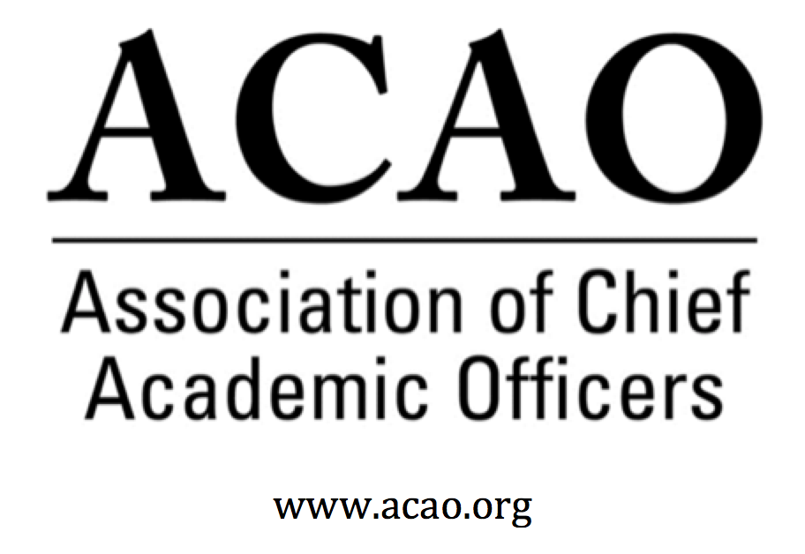
  - Wednesday April 4, 2018 2:00pm ET
Virtual

Agenda & Updates – Martha Potvin
- Approval of March 10 board minutes and March 11 annual meeting minutes
  - Motion: Laura deAbruna - Move to approve minutes
  - 2nd: Beth Ingram – All in favor, motion passes
- A Board of Director group photo will be taken at the July meeting in Seattle.
- Web updates are being worked on. Need officer and committee information to complete. President’s Welcome is complete.
- Digital Fellows – Laura: April 12-15, NOLA Convening 85-90 fellows & team members attending.
  - July convening: Who from the board will be attending? Email your confirmation to Laura and Casey.
- Officers – Martha: Ask Risa to continue as Treasurer. Martha will send request for volunteers to board directors for the Secretary position. The Board will then appoint and notify membership of officers.
- Committees –Martha will also ask for committee volunteers, looking for diversity of individuals and institutions on committees.
- Bylaws/Membership – Martha: Individual v Institutional membership. Bylaws allow for individual membership for sitting Provosts. Not the original intent. Board discussion want to limit individual membership to NON-sitting Provosts. The Bylaw Committee will review language and bring to board and then membership for a vote.
- ACE/ACAO – group with Sherri. Two initiatives:
  - Discussion of the roll of ACAO in programming for CAOs at the ACE annual meeting and Can there be more of a roll for ACAO in ACE’s CAO Leadership Institute?
  - Discussion of a meeting that was agreed to as follow up to the 3/7/18 conference call meeting with ACE representatives (Sherri Hughes, Philip Rogers, Louis Soares, BJ Reed and Martha Potvin). Members of ACAO board (Executive Committee) would appreciate a meeting with Ted Mitchell to re-affirm/clarify a recommit to the ACE/ACAO association relationship.
  - Martha will connect with Sherri
- Ask the Provost – Connie: Sharon Vasquez will flesh out more of the proposal for the board to be discussed/presented at the July board meeting. Board will then decide to move forward.
- Dues renewal – Doreen: Scheduled for April 15th. Doreen has prepared a draft letter. Martha will work with Communications committee to finalize a letter to send with dues renewals.

Attending:
Martha Potvin Mary Boyd
BJ Reed Connie Johnson
Beth Ingram Todd Diacon
Laura de Abruna Rick Miranda
Michele Whelan Sherri Hughes (ACE)
Parvis Ansari Doreen Murner (staff)
Kathy Johnson

