ACAO Board of Directors Meeting Minutes
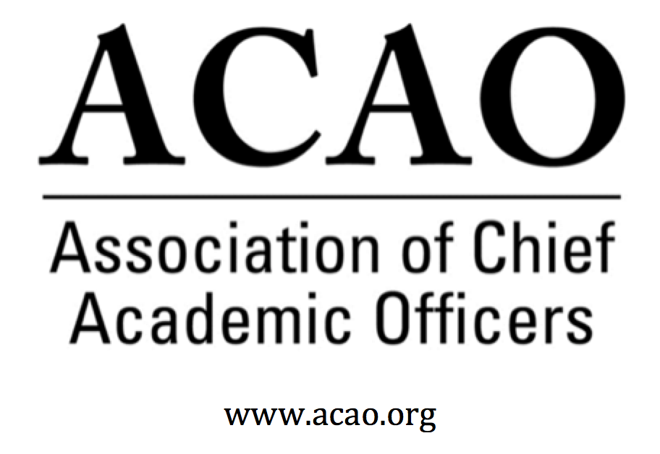

May 1, 2019: https://zoom.us/j/707742741, 2-3 PM (Eastern)

Name | Attend | Name | Attend | Name | Attend
Martha Potvin | Yes | Laura de Abruna | Yes | Michele Wheatly | Yes
Kathy Johnson | Yes | Peter Nwosu | No | Laura Woodworth Ney | No
Mary Boyd | No | Gregory Ochoa | No | Sharon Vasquez | Yes
Gail Baker | Yes | Patricia Rogers | No
Andrew Shean | Yes | Connie Johnson | Yes
Charles Cook | Yes | Todd Diacon | No
Kelli Brown | No | Lori Werth | Yes | Doreen Murner | Yes

- Review and approval of April, 2019 Minutes (K. Johnson)
  - Recommend to approve K. Johnson – All in Favor

- Updates on potential partnerships – e.g., CCAS, AAC&U, Educause, NEASC, etc. (Martha, Kathy, Connie, Sharon et al.) and discussion of how best to align partnerships with our strategic priorities and ensure that we have capacity to support partnerships effectively
  - CCAS – M. Potvin. CCAS would like participation at their Nov 2019 meeting. Potential topic: What deans need to know to step into the Provost role. Martha sent call for program to the program committee to complete.
  - OLC – L. de Abruna. Invited to do a panel on digital learning Nov 4-7, 2019. Maybe also participate in the CAO Institute they offer.
  - Educause – C. Johnson. Interested in an article on the Digital Fellow project authored by Connie & Laura. Also potential panel session at the Oct conference on potential roles of the CAOs and CIOs. Connie will write proposal. Horizon Report, short term trends on blended learning/flipped classes. Potential for a joint webinar on topic. Educause is willing to incorporate ACAO work into their member outlets.
  - NEASC – S. Vasquez. Potential opportunity for an ACAO hospitality suite or reception at their Dec 2019 meeting. There is interest in provosts & accreditation.
  - HERS – S. Vasquez. Women’s leadership org. They do have a leadership program, Next Stages Next Steps for executive women in higher ed. Verna Fitzsimmons is the ED and will meet with Sharon next week.
  - AAC&U – K. Johnson. Would like to partner on a potential provost institute (as ACE exists that space) and maybe a possible provost track at their conference.
  - Discussion on Commission on Academic Affairs who mostly represent large publics. ACAO’s niche is broader to include small, community colleges & privates.

- Advisory Council report (Sharon)

  - Virtual Coffee Hours – S. Vasquez updated coffee hr registrations. 6 Coffee Hrs with 80 registrations but far fewer attended, estimate at 35. Still in beta of recording coffee hrs to publish on the web site for those members that missed them. Ask A Provost program has had zero inquiries. Maybe look at re-aligning form to move “terms” to the end after a question is posed. This may remove any perceived barriers.

  - Review of Nominees to Advisory Council (BJ Reed and Gail Wells – bios sent together with agenda). Board recommended to approve new council members. Kathy motioned – All in favor

- Mentoring for New CAOs - Pausing Before Jumping In (Kathy)

  - Possible step 1 – soliciting board “pockets of expertise” on topics such as: enrollment management, unions, responsibility-centered management, school mergers/reorganizations, creation of branch campuses, online program expansion, adaptive learning technologies, strategic international partnerships, University College models, ______, _____, ________)

  - Need careful consideration of how this interfaces with Ask a Provost

  - Programming Committee needs a new leader…and is getting stretched thin

  - Also, to involve Advisory Council to make connection with new members on how things are going and maybe get some potential questions / discussion to begin mentoring. Need to be careful how it overlaps with Ask A Provost.

- ACE Engage Platform (Connie et al.)
  - 3-4 board directors on the beta Engage platform. It’s new & very nice but content is limited. There is potential to develop/share content from ACAO to ACE.

- Membership Renewals (Doreen) – Discussion of how Membership & Communication committee members might provide support for this work. Committee is meeting this month.

- Committee and Officer Assignments (K. Johnson) – Timeline for determination of priorities for upcoming year.
  - Looking at membership wide call for volunteers to help. And will discuss at July meeting

- New Business
  - ACAO web site: C. Johnson – will work the Lori Werth & Doreen to remove/archive “old” content. Then see what’s left & move potential new content over.
  - Bylaw change needed to bring in additional board members when current directors leave. M. Potvin will look at potential bylaws change. Board will think about potential directors as alternatives to step in.
  - Summer Meeting: Thursday July 18, 2019 @ ACE HQ – Dupont Circle, Washington, DC.
July 17: Travel to DC. Group dinner @ 6pm (location TBD) for those that can make it.
July 18: Meeting 8-3pm. 8-9am continental breakfast @ ACE. Travel home after 3pm.

Future Board Meetings: (typically the first Wednesday of the month at 2 PM, eastern)
- June 5, 2019 2:00pm ET
- July 18 summer meeting @ ACE Headquarters, Washington DC

Standing Committee Descriptions:
- Communications and Membership: The purpose of this committee is to oversee and manage communications between the association and its membership (in consultation with ACAO leadership), primarily aimed at recruiting and retaining members. Includes developing member- communications that cultivate a distinctive ACAO identity and brand, developing strategies and materials to generate interest in joining ACAO. Members also will use professional contacts to encourage membership, report on membership, and make recommendations about dues. Members will work at generating communications materials and strategies directed toward building membership.
- Nominating: The purpose of the Nominating Committee is to develop and manage the process by which candidates for the governing board are presented to the membership for election. This includes soliciting the membership for nominations and applications for board positions and developing a slate of candidates. The Nominating Committee is also responsible for overseeing the election process and informing the membership of the results
- Annual ACE Programming: The purpose of the Annual Program Committee is to coordinate the program held at the annual meeting. Committee members will identify topics and coordinate speakers and program activities relevant to CAOs and CAOs/presidents/chancellors in the academic and higher education area. [NOTE – THIS IS GOING TO GET BROADER AS PARTNERSHIPS EXPAND AND PROGRAMS INCREASE]
- Bylaws: The bylaw committee is charged with reviewing ACAO's bylaws and bringing any changes/recommendations to the ACAO board of directors for consideration.
- Finance: The Finance Committee provides guidance to the board to ensure the financial health of the organization, according to sound fiscal policies. The committee shall periodically review and revise investment policies, financial and audit documents and fiscal policies of ACAO and make recommendations to the board.

Executive Committee | Director | Role/Committee | Institution | Term Ending
 | Kathy Johnson | President | IUPUI | 2020
 | Kelli Brown * | President-Elect  Responsibility: Chair of ACE Program Committee | Georgia College and State University | 2021
 | Doreen Murner | Executive Director | AMC Source | n/a
 | Martha Potvin | Past-President  Responsibility: Chair of Nominating Committee | Springfield College | 2020
Directors | Gail Baker |  | University of San Diego | 2022
 | Mary Boyd | Treasurer | Berry College | 2020
 | Charles Cook | Membership & Communications | Austin Community College | 2021
 | Laura Niesen de Abruna | PI: Digital Fellows Project  Finance Committee | York College of Pennsylvania | 2021
 | Todd Diacon | Nominating | Kent State University | 2020
 | Connie Johnson | ACE Program | Colorado Technical University | 2020
 | Gregory Ochoa | Chair: Membership & Communications | Potomac State College of West Virginia University | 2021
 | Peter Nwosu | Membership & Communications | Lehman College of CUNY | 2021
 | Patricia Rogers * | n/a | Winona State University | June, 2019
 | Andrew Shean |  | National University System | 2022
 | Sharon Vasquez | Chair: Advisory Council (ex officio) | Provost Emerita, University of Hartford | 2020
 | Lori Werth |  | University of Pikeville | 2022
 | Michele Wheatly |  | Syracuse University | 2022
 | Laura Woodworth-Ney |  | Idaho State University | 2022
*Assuming new roles by July 2019.

