ACAO Board of Directors Meeting Minutes
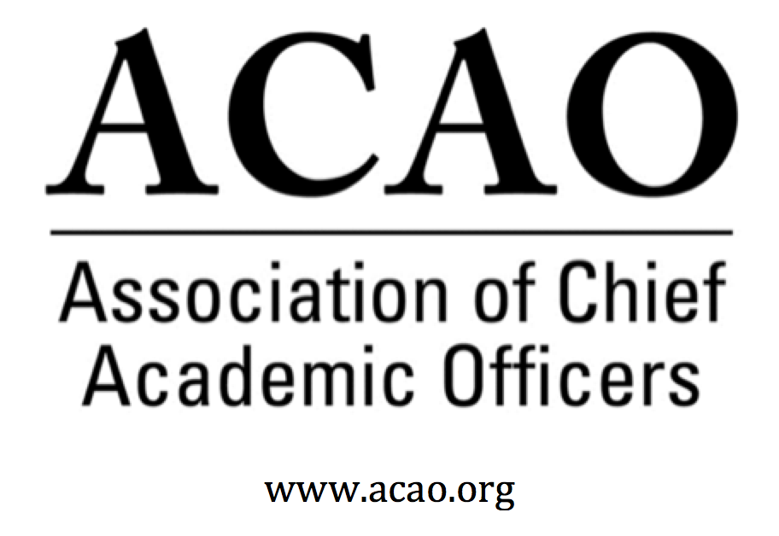

December 5, 2019: https://zoom.us/j/707742741, 2-3 PM (Eastern)
Name | Attend | Name | Attend | Name | Attend
Martha Potvin | Yes | Laura de Abruna | Yes | Michael Evans | Yes
Kathy Johnson | Yes | Peter Nwosu | No | David Manderscheid | Yes
Mary Boyd | Yes | Gregory Ochoa | No | Scott Newman | Yes
Gail Baker | Yes | Michele Wheatly | Yes | Constance St Germain | Yes
Andrew Shean | No | Connie Johnson | Yes | Patricia Salkin | Yes
Charles Cook | No | Laura Woodworth-Ney | No | April Mason, Adv Cncl | Yes
Beth Ingram | Yes | Lori Werth | Yes | Doreen Murner | Yes

- Review and approval of November Board Meeting Minutes (K. Johnson)
  - M.Potvin motion to accept. De Abruna second. All in favor. Motion passes
- Potential New Partnership: The Convergence Forum (M. Boyd, K. Johnson)
  - Forum designed to bring together CAOs, CIOs & CFOs to discuss topics of interest to all groups. More CAOs needed to participate. M. Boyd will lead / liaison with the groups/Educause. Concept is to bring people together to breakdown silos and chart the future. Good idea for potential partnership…all agreed to move forward.

Agenda from 2019 Convergence Forum (2020 Agenda in Development)

- Planning for ACE Annual Meeting

  - Board Meeting: Saturday, March 14, 10-3:30 PM at University of San Diego (20-30 minute drive from Marriott)
    - Potential topics:
      - ROI of ACAO membership – only affinity group of CAOs, sense of community, discuss similar challenges and successes
      - Making the case for academics – the value of higher education
      - DF strategies and engagement
      - Listserv for CAOs
      - Valued partnerships, Educause, AAS&U, APLU, Titan Partners
      - Financial & Membership reports

  - Reception for Chief Academic Officers: (4:30 – 6 PM, Roy’s at the Marriott Marquis ): Saturday, March 14
    - ACE agreed to send invite to ACAO Provost Reception to all attending CAOs.
    - Board members to welcome incoming reception attendees one on one, personal connection.
    - K. Johnson/M. Boyd to welcome everyone & pitch membership value…why we’re important to ACE and the community in general

  - ACAO Breakfast for Chief Academic Officers and Business Meeting: Sunday, March 15, 7:30 – 9:30 AM
    - Breakfast 7:30-8:00am; Business Mtg 8:00-8:30am; Programming 8:30-9:30am. D. Murner to ask ACE to include timing in their program.
    - Programming content delivered in a “speed dating” format. 15 minute table discussions for 60 mins. – Some table discussion on dealing with change as it leads into the ACAO co-facilitated session on Leading Institutional Change (below)

  - ACAO co-facilitated session (S. Newman)
Title: Leading Institutional Change: The Academic Leader’s Toolkit
Evolving business models, shifting learner demographics, technological advancements and countless other external and internal forces are requiring academic leaders to direct significant time and energies to leading major institutional change initiatives. During this session, seasoned chief academic officers will present case studies of major change efforts they were responsible for leading, as well as explore key lessons gained through those experiences regarding what did and did not work. Attendees will be encouraged to ask questions and/or share insights from their own experiences with and/or observations of change initiatives. The goal of this session is to help participants identify insights, strategies and tips that may be useful in the development their own toolkits for leading change.

Session Format
- Seating for 60 people
- Laptop, screen, projector, wireless remote
- Two wireless handheld microphones
  - Send panelist names and moderator names to S Newman. Community college participant is desired.

- Advisory Council Updates A. Mason -
  - Blog work continues using the previous coffee hrs. Adds to member ROI.

- Other Board Matters:

- Nominations for Board Members (for electronic ballot in advance of ACE meeting) and potential solicitation of nominees through the listserv (Martha Potvin)
  - C. Johnson, M. Wheatly & M. Potvin rolling off. 3 positions open
  - Board nominees:
    - Pam Stinson
    - Junius Gonzalez
    - John McCarthy
    - Other candidates will be asked to serve as alternates
- Other Transitions (Thanks to Michele Wheatly)
- Committee Reports
  - DLC – session at OLC on adaptive learning.
  - Worked with Educause survey to get CAOs to participate.
- New Business

Next Board Meeting: (January, 2020 meeting is CANCELLED); February 5, 2020, 2 PM (Eastern)

Board of Directors: Assigned Roles
Executive Committee | Director | Role/Committee | Institution | Term Ending
 | Mary Boyd | Treasurer/President-Elect | Berry College | 2020/2022
 | Kathy Johnson | President | IUPUI | 2020/2021
 | Doreen Murner | Executive Director | AMC Source | n/a
 | Martha Potvin | Past-President  Responsibility: Chair of Nominating and  Bylaws Committees | Springfield College | 2020
 | Gail Baker | Editorial Team  Secretary | University of San Diego | 2022
Directors | Charles Cook | Membership & Communications | Austin Community College | 2021
 | Laura Niesen de Abruna | PI: Digital Fellows Project  Finance Committee  Editorial Team  Digital Learning Cmte-Chair  Innovation & Strategies | York College of Pennsylvania | 2021
 | Michael Evans | Finance Committee | Southern New Hampshire University | 2020 (slate in 2020 for 3Y)
 | Connie Johnson | Professional Development  Editorial Team  Digital Learning Committee | Colorado Technical University | 2020
 | Beth Ingram | Treasurer-Elect  Membership & Communications | Northern Illinois University | 2021
 | David Manderscheid |  | University of Tennessee, Knoxville | 2020 (slate in 2020 for 3Y)
 | Scott Newman | Professional Development Committee | Oklahoma State University Institute of Technology | 2020 (slate in 2020 for 3Y)
 | Gregory Ochoa | Chair: Membership & Communications  Digital Learning Committee | Potomac State College of West Virginia University | 2021
 | Peter Nwosu | Membership & Communications  Innovation & Strategies  Digital Learning Committee | Lehman College of CUNY | 2021
 | Patricia Salkin |  | Touro College | 2020 (slate in 2020 for 3Y)
 | Andrew Shean | Innovation & Strategies  Digital Learning Committee | National University System | 2022
 | Constance St. Germain |  | Capella University | 2020 (slate in 2020 for 3Y)
 | Sharon Vasquez | Chair: Advisory Council (ex officio) | Provost Emerita, University of Hartford | 2020
 | Lori Werth | Professional Development  Innovation & Strategies | University of Pikeville | 2022
 | Michele Wheatly | Membership & Communications | Syracuse University | 2022
 | Laura Woodworth-Ney |  | Idaho State University | 2022
*Additional Professional Development Committee Member: Ellen Granberg, Provost, Rochester Institute of Technology

