ACAO Board of Directors Minutes
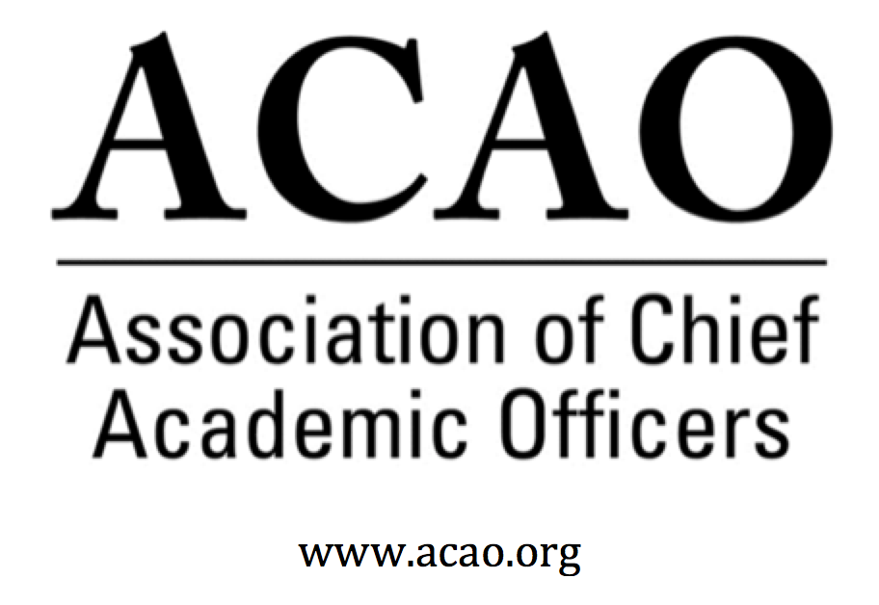

June 6, 2018

June 6, 2018
1:00pm Central/ 2:00pm ET

Attendance/Roll call:

Name | Attend | Name | Attend | Name | Attend
Martha Potvin |  | Laura de Abruna |  | Michaele Whelan | x
Kathy Johnson |  | Peter Nwosu |  | BJ Reed | x
Risa Palm | x | Gregory Ochoa |  | Rick Miranda
Parviz Ansari | x | Patricia Rogers |  | Todd Diacon | x
Mary Boyd |  | Vincent Solis | x | Kevin Carman
Charles Cook | x | Connie Johnson |  | Beth Ingram | x
Kelli Brown | - c | Doreen Murner

- May 2, 2018 Board Minutes – Vote to approve – M. Potvin (attached).
  - Board approved minutes
- Strategic Plan review with Committee input/assignments (attachments: SP & Committee Charges)
  - Martha requests all committees meet to determine status of objectives & recommendations moving forward. Metrics for measurement of success and progress need to be determined. It is possible that new committees will be required.
  - There was agreement that “Broadening our resource base” should be incorporated into the plan to encourage grant applications to foundations and other potential sources of funding.
- Financial report – Treasurer
  - Laura reported that April reported an infusion of an additional $200k from Gates Foundation.
  - Martha: is there an opportunity to source additional grants? To broader our resource base?
- Membership report – Renewal / Acquisition update
  - Doreen reported approximately 23% have renewed. And an additional 8 NEW members acquired.
  - Lapsed member calls to begin July 1. Then calls to Non-renewed current members. And a campaign to “prospects”.
  - Second renewal notice sent May 28th to those not yet renewed.
  - Third renewal notice scheduled to send prior to June 30th.
  - There was discussion about who should receive invoices and a suggestion was made that administrative assistants should be copied.
- Advisory Council report – Connie Johnson
  - Ask A Provost update from attorney (attached document)
    - Council retained to review & recommend disclaimer. Board in agreement to move forward with program.
  - Advisory Council’s roles & responsibilities
    - Questions concerning vetting of council members who are providing advice. The Advisory Council is working on guidelines and an onboarding process for giving answers to member questions. Advisory Council will finalize for July meeting.
    - At the July meeting, the ACAO board will define what the Council will work on for the year.
  - May Coffee Hour update – Doreen Murner - Doreen reported 17 registrations in total minus board/advisory council, 13 participants registered. However, only 2 showed up. WHY? Several concerns were noted: time of year is not good – graduation, end of term. Marketing needs some attention to push more often.
- Digital Fellows report - Laura de Abruna
  - Peter suggested to use extra grant funds to present proposals at regional meetings. Laura will share at July board meeting of Digital Solution Learning Network and future funding from the Gates Foundation. We currently have proposals for regional meetings from Clark Atlanta University, UNLV, and the UNC system.
  - Laura plans to submit a proposal for an additional 3 years of funding.
- Bylaws
  - We have received a request to include all 19 campuses in a system under a single membership and to allow deans access to ACAO materials. Kathy suggested the possibility of “cutting a deal” for system membership. These questions need to be discussed by the board and bylaws revised as appropriate.
- July Board meeting
  - July 26, 2018, Seattle. Currently scheduled 9:00am – 3:00pm. Meeting will take place at the Gates Foundation, a short walk from the hotel.
  - If you are attending the Digital Fellows Convening we need to know:
Please note that I need to know the names of all non-DF Board members who plan to attend the Convening, which begins with dinner on Monday evening and runs through noon on Wednesday. For meal counts and other purposes, I need to know your plans and the plans of other Board members for:
— dinner on Monday, July 23 (@ Crow)
— Tuesday meeting, July 24
— dinner on Tuesday (@ Collections)
— Wednesday morning meeting, July 25

- New Business

Future Board Meetings
Jun 6, 2018 2:00 PM
July 26 - face to face meeting in Seattle
Aug 1, 2018 2:00 PM
Sep 5, 2018 2:00 PM
Oct 3, 2018 2:00 PM

