ACAO Board of Directors Meeting
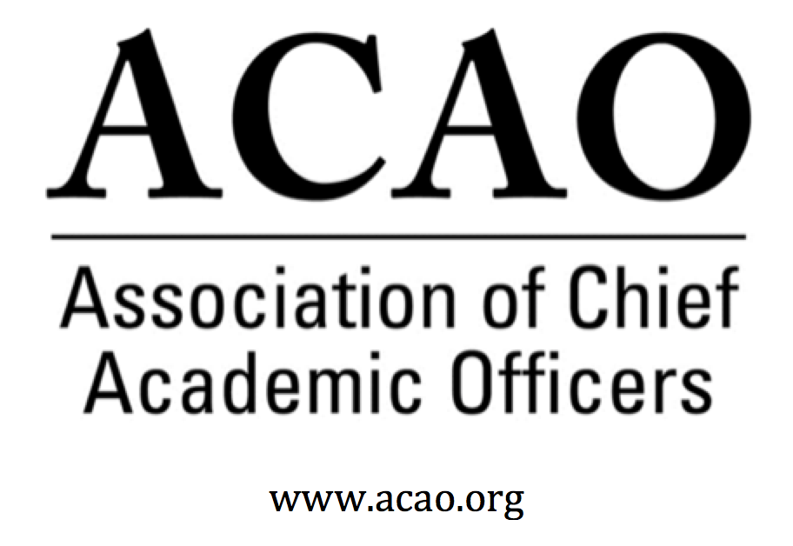

Minutes

February 6, 2019 Conference Call

Name | Attend | Name | Attend | Name | Attend
Martha Potvin | Yes | Laura de Abruna | Yes | BJ Reed | Yes
Kathy Johnson | Yes | Peter Nwosu | No
Mary Boyd | Yes | Gregory Ochoa | Yes
Rick Miranda | No | Patricia Rogers | No
Kevin Carman | Yes | Michaela Whelan | No
Charles Cook | No | Connie Johnson | Yes | Doreen Murner | Yes
Kelli Brown | No | Todd Diacon | No

- 12/12 and 1/25 Minutes – Vote to approve – M. Potvin
  - Mary B motioned to approve 12/12 board minutes, K Carman 2nd. All in favor
  - Mary B motioned to approve 1/25 board minutes, K Carman 2nd. All in favor

- ACE/ACAO MOU Update: M. Potvin
  - ACE Engage Platform @ ACAO Board meeting 3/9th. Nicole & Louis will present platform to ACAO board.

- Strategic Plan Update – K. Johnson
  - Vote to endorse revised strategic plan – Tabled until 3/9th meeting.
- Bylaws revision – proposed adjustment needed for 3/9th meeting to combine membership and communications committees, since there is a lot of overlap of work. And to increase scope of the programming committee to be more than just the annual meeting programming.

- Membership – discussion of calls and results/growing membership. Growth is slow but steady, not a windfall. Board directors sent emails to the “lapsed” group of members. G. Ochoa noted that we may consider having a more permanent contact individual within academic affairs that would remain consistent over time due to the turn-over of the provost office. Send an email along with the dues renewal to forward administrators contact information to ACAO’s office. K. Carman offered to update membership brochure.
Second wave of membership outreach would be for each board director to focus on their state contacts for new members.

- Financial – Membership is key to growth, since it is the only source of revenue.
- Advisory Council

  - Potential name change under discussion and consideration. Name doesn’t reflect what the Council does to support the board and membership. Should some of their work expand to helping with membership or be more functional to help the board. Alternatives for a name: Sr Fellows, other?
  - C Johnson & K Johnson will talk with Adv Council to discuss their role and what they would like to work on.

- Nominations – Vote to accept slate of candidates – All in favor

