ACAO Board of Directors Meeting Minutes
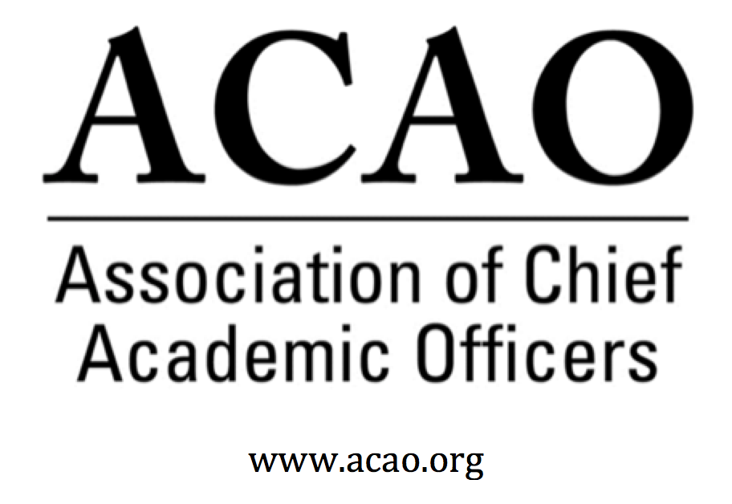

October 2, 2019: https://zoom.us/j/707742741, 2-3 PM (Eastern)

Name | Attend | Name | Attend | Name | Attend
Martha Potvin | Yes | Laura de Abruna | Yes | Michael Evans | Yes
Kathy Johnson | Yes | Peter Nwosu | Yes | David Manderscheid | Yes
Mary Boyd | Yes | Gregory Ochoa | Yes | Scott Newman | Yes
Gail Baker | Yes | Michele Wheatly | Yes | Constance St Germain | Yes
Andrew Shean | Yes | Connie Johnson | Yes | Patricia Salkin | Yes
Charles Cook | No | Laura Woodworth-Ney | No | Sharon Vasquez, Adv Cncl | Yes
Beth Ingram | Yes | Lori Werth | Yes | Doreen Murner | Yes

- Review and approval of September Board Meeting Minutes (K. Johnson)
  - Motion to approve – P. Nwosu; 2nd L. Werth. All approve – motion passes
- Board of Directors Matters

  - Proposed New Committee (below) – discussion of timing of launch of Innovation and Strategies Committee (Laura Neisen de Abruna and Kathy Johnson)
    - Committee changes are to align current committee structure to dovetail with the goals of ACAO.

NEW: Digital Learning Committee (Chair: Laura Neisen de Abruna): In accordance with the mission and goals of ACAO to develop membership expertise in high impact practices that deepen student learning, and as required by the terms of the ACAO grant of 2016-2020 from the Bill & Melinda Gates Foundation, there will be established a Committee on Digital Learning as a standing committee of the ACAO board. This committee will be charged with providing information, training, resources, and support for CAOs who are interested in learning more about the potential of digital learning to increase student success. To increase the value of the ACAO website, the committee will be responsible for updating the ACAO assets on digital learning and for the vetting of products and services. While the committee will extend and disseminate the information generated by the thirty-two Digital Fellows who were part of the 2016 Bill & Melinda Gates Foundation grant, their role moving forward will be to pursue new grants, contracts, and partnerships that will provide more opportunities for more CAOs to learn about the potential of digital learning to increase student retention and persistence to graduation.
L. De Abruna discussed requirement and formation of this committee. Based on discussion all agreed to pause with the Innovation and Strategies Committee and focus on the Digital Learning Committee. The Innovation & Strategies Committee will remain in the bylaws with a focus in 2021. The Digital Learning Committee will be added to the bylaws. All agreed the work of the Digital Fellows is a signature program for ACAO. DLC will also use the ACAO to hold current and future resources for members.
DLC volunteer members: Peter Nwosu, Greg Ochoa, Andrew Shean. L de Abruna will ask general membership for volunteers.
- Conversation with ACE Leadership Regarding Annual Meeting, MOU, etc. (Kathy Johnson and Mary Boyd)
  - K. Johnson & M. Boyd met with ACE leadership, N. Woods & P. Rogers. Annual Meeting programming will change. Number of sessions will be reduced and the event will be shortened by a day. Intent is for the regional convenings to pick up the topical content normally at the Annual Meeting. ACE anticipates there will be a net gain on sessions via the regional convenings. We need to develop a strategy on how to maximize opportunities at the regional convenings. ACAO has been invited to have a session for CAOs, designed entirely by ACAO and branded to ACAO. Professional Development Committee will pull this together. ACAO annual business meeting will be held Sunday am. Opportunity for ACAO programming to be added and it will be open to all provosts in attendance.
  - Board meeting will be held Saturday at University of San Diego, potential time frame 11am-3pm. Sat evening ACAO will host a reception for all attending provosts.
  - Will ask ACE to help us promote reception so CAOs know in advance. Suggestion is to have ACE send out targeted emails to provosts & CAOs who register.
  - MOU with ACE will stay in place until after the ACE meeting.

  - Brainstorming of topics for ACE session (to be developed by Professional Development Committee)

    - Session at ACE needs to be more than a panel discussion. Requirement is to be more interactive and may be have a take-a-way for attendees. Pro D Committee to pull together several case studies and create a packet as a take-a-way.
    - Mental health issues & crisis. How do we provide support for students, faculty & staff. Maybe focus on academic leadership, how to get deans and faculty to focus on mental health support.
    - Free speech/Hate speech controversy. How to lead through disruption.
    - Scholarship and the changing definition in the digital age.
    - Umbrella topic – Managing or Juggling Change

- Committee reports and updates:
Membership & Communications: Greg Ochoa
    - Committee met. Lapsed members were sent a letter by D. Murner/L. Rome. Several renewals matriculated but still need more. K. Johnson & G. Ochoa to write a letter (peer to peer) to a: Join or b. Renew. Those that decline will receive a short survey. Phone outreach will happen after the letters.
    - G. Ochoa wants to create an ACAO flyer that can be emailed to potential members. Wants to include all ACAO events, ACE meeting, member testimonials, etc.
    - Discussion of including associate provosts as members. It will help with institutional consistency when the provost moves out of the position.

Professional Development: Kathy Johnson : See discussion above. Pro D needs a chair.

- Update/Feedback from the Advisory Council: Sharon Vasquez
    - Council members committed to 5 blog topics, based on the past coffee hrs.
    - Council members would like to participate as ex-officio on committees that have a need or where there is an interest. April Mason volunteered for Membership & Communications. BJ Reed volunteered for Innovation & Strategies.

- Old Business

  - ACAO Blogging for Higher Education Today proceeding well – first two contributions archived in Google Drive
    - First blog published Monday.

  - Discussion of Potential ACAO response to AIR/Educause/NACUBO Joint Statement on Analytics (Mary Boyd and Connie Johnson)

    - The Association of Chief Academic Officers (ACAO) strongly supports the EDUCAUSE, AIR and NACUBO joint statement, “Analytics Can Save Higher Education. Really”. ACAO agrees that data are an institutional strategic asset that is critical in a decision making process. Particularly relevant to the role of the CAO is the understanding that use of data analytics can strengthen student outcomes and institutional efficiency. The CAO is a catalyst to increased engagement with data analytics by supporting faculty and academic leadership to make data-driven decisions in supporting student success and innovation in the classroom. Letter will be published on ACAO’s website.
    - J. O’Brien is interested in a session with ACAO for Educause meetings
    - AIR/Educause/NACUBO hosted a “twitter chat” on the analytics document. C. StGermain & M. Boyd participated on behalf of ACAO.

  - ACE Annual Meeting and Reception for CAOs (Kathy Johnson) Discussed above
  - Partnership Updates

- New Business

Future Board Meetings: (typically the first Wednesday of the month at 2 PM, eastern); November 6, 2019; December 4, 2019 [Note: In-person winter meeting to be held at University of San Diego on March 14, 2020]

Board of Directors: Assigned Roles
Executive Committee | Director | Role/Committee | Institution | Term Ending
 | Mary Boyd | Treasurer/President-Elect | Berry College | 2020/2022
 | Kathy Johnson | President | IUPUI | 2020/2021
 | Doreen Murner | Executive Director | AMC Source | n/a
 | Martha Potvin | Past-President  Responsibility: Chair of Nominating and  Bylaws Committees | Springfield College | 2020
Directors | Gail Baker | Editorial Team  Secretary | University of San Diego | 2022
 | Charles Cook | Membership & Communications | Austin Community College | 2021
 | Laura Niesen de Abruna | PI: Digital Fellows Project  Finance Committee  Editorial Team  Digital Learning Cmte-Chair  Innovation & Strategies | York College of Pennsylvania | 2021
 | Michael Evans | Finance Committee | Southern New Hampshire University | 2020 (slate in 2020 for 3Y)
 | Connie Johnson | Professional Development  Editorial Team  Digital Learning Committee | Colorado Technical University | 2020
 | Beth Ingram | Treasurer-Elect  Membership & Communications | Northern Illinois University | 2021
 | David Manderscheid |  | University of Tennessee, Knoxville | 2020 (slate in 2020 for 3Y)
 | Scott Newman | Professional Development Committee | Oklahoma State University Institute of Technology | 2020 (slate in 2020 for 3Y)
 | Gregory Ochoa | Chair: Membership & Communications  Digital Learning Committee | Potomac State College of West Virginia University | 2021
 | Peter Nwosu | Membership & Communications  Innovation & Strategies  Digital Learning Committee | Lehman College of CUNY | 2021
 | Patricia Salkin |  | Touro College | 2020 (slate in 2020 for 3Y)
 | Andrew Shean | Innovation & Strategies  Digital Learning Committee | National University System | 2022
 | Constance St. Germain |  | Capella University | 2020 (slate in 2020 for 3Y)
 | Sharon Vasquez | Chair: Advisory Council (ex officio) | Provost Emerita, University of Hartford | 2020
 | Lori Werth | Professional Development  Innovation & Strategies | University of Pikeville | 2022
 | Michele Wheatly | Membership & Communications | Syracuse University | 2022
 | Laura Woodworth-Ney |  | Idaho State University | 2022
*Additional Professional Development Committee Member: Ellen Granberg, Provost, Rochester Institute of Technology

