ACAO Board of Directors Meeting Minutes
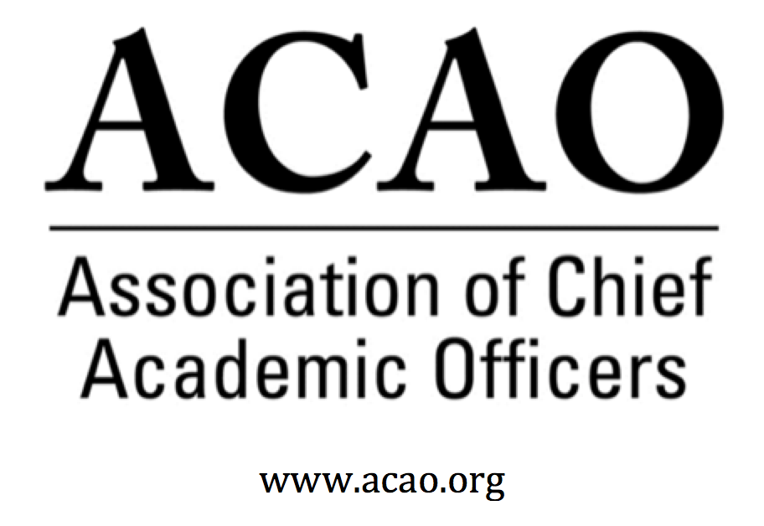

June 3, 2020: https://zoom.us/j/707742741, 2-3 PM (Eastern)

Name | Attend | Name | Attend | Invited Guests | Attend
Mary Boyd |  | Pam Stinson |  | Junius Gonzales
Gail Baker |  | Greg Ochoa |  | John McCarthy
Kathy Johnson |  | Peter Nwosu |  | Michael Quillen
Beth Ingram |  | Patricia Salkin
Scott Newman |  | Andrew Shean
Laura de Abruna |  | Constance St Germain
Michael Evans |  | Lori Werth
Connie Johnson |  | Laura Woodworth-Ney
David Manderscheid |  | April Mason/Adv Cl |  | Doreen Murner

- Review and approval of May Board Meeting minutes. May's Minutes M. Boyd - Call for discussion/updates.
    - Motion to approve – Minutes pass with concurrence of the board

- Board transitions and current positions: Secretary position filled, Michael Evans
    - M. Boyd introduced M. Evans as new Secretary

- Board transitions: David Manderscheid has resigned to move back to faculty. Discussion of adding candidates from prior nomination cycle.

  - Heather Coltman, James Madison Univ.
  - Sasha Kopp Univ. of Nebraska- Omaha

Above are names from earlier nomination periods. M. Boyd asked if anyone knows either of the potential candidates. L. de Abruna discussed representation of the candidate to fill in any board gaps. B.J. Reed is from Nebraska Omaha & S. Kopp is also from Nebraska Omaha and we’ve had that perspective for a number of yrs. Consensus of the board is to work with H. Coltman first and if she declines to work with S. Kopp.

- Bylaw changes – Board to recommend changes to the membership. Proposed Bylaw Changes

Proposed Bylaws Clean Version Board votes to approve & recommend changes to the membership. The membership will then vote. - K. Johnson

K. Johnson discussed changes to the board. It is noted in section 11 that newly elected board directors should be taking an oath of office. Suggestion is to take Section 11 and ask board directors to abide by the responsibilities and sign. D. Murner will send section to all board directors and board directors sign & return. K. Johnson acknowledged bylaws are ready to submit to the membership. They will be submitted to the membership for the July 14th Members Business Meeting.

- ACAO Member virtual Business Meeting – Association update on financials, membership & vote on bylaws, certify elections. Date is July 14, 2020 @ 1pm ET.

K. Johnson suggested that maybe we have a “member share” (zoom rooms) during the business meeting to engage the members with more than just the business of ACAO. A. Mason agrees with the idea to do something more than just business. Use as an opportunity to engage membership. S. Newman will work with C. Johnson & L. Werth to look at the topics and pivot to a virtual meeting. L. de Abruna offered to do a breakout room on the Tyton Partners survey of 4000 faculty members on what did we learn from Spring 2020. ACAO provided over 300 faculty responses. Second survey could be what are you planning for the fall. L. de Abruna will work with Tyton Partners on creating a session.

- AMC Source Discussion – M. Boyd, B. Ingram
    - Have not had the conversation yet

- Committee Updates

  - Digital Learning Cmte – L. de Abruna – Tyton survey update
    - FYI: L. de Abruna: #1 take a way – students had trouble staying motivated due to the virtual delivery, felt isolated.
    - L. de Abruna is working on a grant with APLU and ACAO with the Gates Foundation on helping faculty members get ready for the fall. Will know more within a week. L. de Abruna will provide an update when information is known.

  - Professional Development – S. Newman – Provost Town Halls

    - SCHEDULED
    - Budgeting Under Uncertainty – June 3, 2020 @ 12pm ET (collaborators B. Ingram, P. Nwosu, K. Johnson)
    - What Will the Fall Semester Look Like – (tentative) June 30, 2020 12pm ET (collaborators L. de Abruna, D. Manderscheid, P. Salkin)

ii. Additional proposed topics:
• Changing Landscape of Faculty Roles & Responsibilities in Higher Education
• Leading & Managing Teams Remotely
• Preparing for the 21st Century Digital Learner -- Post Spring 2020
• CAO Lessons in a Post-Pandemic World

S. Newman would like to select one or two more topics to create future town halls. Discussions of each topic to see which ones bubble to the top. P. Salkin asked for others who would join her on what does the fall semester look like. P. Nwosu volunteered. J. McCarthy volunteered.
K. Johnson proposed looking at the topic of CAOs leading anti-racism on campus. G. Ochoa volunteered to work on this panel with K. Johnson and G. Baker. Should be scheduled very soon. M. Boyd suggested to move the June 30th town hall to sometime in July and have the June 30th town hall to focus on anti-racism. A. Mason suggested to market our events via the ACE Engage Platform. P. Salkin would like revised schedule with dates of town halls and business meeting. July 28th is scheduled for the town hall on what will the fall semester look like

  - Innovation & Strategies – L. Werth –
    - Committee members would like to co-sponsor the Tyton Partners survey town hall on July 21st. P. Salkin will accept invitation to work on the Tyton Partners survey and work with the second survey on what will the fall look like.
    - L. de Abruna will send out marketing info to get out to the members. L. Werth talked about two other initiatives the committee is working on. Writing on the calendaring implications for institutions and publish in Inside Higher Ed. The other is acquiring a grant on topics related to what is going on now and creating a research team with faculty and provosts.

  - Membership – G. Ochoa –
    - Committee met today. Membership committee would like to connect with the other committees to work on engaging with non-members to get them to join (i.e. Pro D Committee).
    - Suggestion by M. Boyd to talk about how to join ACAO after each town hall

- Advisory Council – A. Mason
Discussed transitions of the Council. Two other members have decided to step down, Margaret Winters and Gayle Davis, along with Sharon Vasquez. Therefore, the Council is looking to recruit new Council members. Looking at the Council purpose statement and deciding if the Council needs bylaws. Blogs are being sent to ACE. Council would like to assist the board as much as the board would like.

- ACE update. (K. Johnson and M. Boyd)
    - M. Boyd discussed the MOU. ACAO can hold future meetings at ACE HQ in DC. ACE is looking for content for the Engage platform. Consensus of the board, the MOU is accepted with the understanding if there is another ACE annual meeting that ACAO can host the Members Business Meeting and Provost programming.

- Our next regularly scheduled board meeting is July 1, 2020 @ 2pm ET

2020 Board of Directors: Assigned Roles
Executive Committee | Director | Role/Committee | Institution | Term Ending
 | Mary Boyd | President | Berry College | 2020/2022
 | Kathy Johnson | Past President Responsibility: Chair of Nominating and  Bylaws Committees | IUPUI | 2020/2021
 | Gail Baker | President Elect  Editorial Team | University of San Diego | 2022
 | Beth Ingram | Treasurer | Northern Illinois University | 2021
 | Michael Evans | Secretary | SHNU | 2023
 | Doreen Murner | Executive Director | AMC Source | n/a
 | Laura Niesen de Abruna | PI: Digital Fellows Project  Finance Committee  Editorial Team  Digital Learning Cmte-Chair  Innovation & Strategies | York College of Pennsylvania | 2021
 | Gregory Ochoa | Chair: Membership & Communications  Digital Learning Committee | Potomac State College of West Virginia University | 2021
 | Peter Nwosu | Membership & Communications  Innovation & Strategies  Digital Learning Committee | Lehman College of CUNY | 2021
 | Connie Johnson | Professional Development  Editorial Team  Digital Learning Committee | Colorado Technical University | 2022
 | Andrew Shean | Innovation & Strategies  Digital Learning Committee | National University System | 2022
 | Lori Werth | Professional Development  Innovation & Strategies | University of Pikeville | 2022
 | Laura Woodworth-Ney | Innovation & Strategies | Idaho State University | 2022
 | Michael Quillen | Membership Committee | Rowan-Cabarrus Community College | 2022
 | TBD | Finance Committee |  | 2023
 | Scott Newman | Professional Development Committee | Oklahoma State University Institute of Technology | 2023
 | Patricia Salkin | Membership Committee | Touro College | 2023
 | Constance St. Germain | Finance Committee | Capella University | 2023
 | Junius Gonzales | Professional Development | NY Institute of Technology | 2023
 | John McCarthy | Membership Committee | UMass – Amherst | 2023
 | Pam Stinson | Professional Development | Northern Oklahoma College | 2023
 | April Mason | Chair: Advisory Council (ex officio): Ex Officio: Membership & Communications Cmte
*Additional Professional Development Committee Member: Ellen Granberg, Provost, Rochester Institute of Technology
*BJ Reed, Innovation & Strategy Committee Member: Ex officio Advisory Council rep

