ACAO Board of Directors Minutes
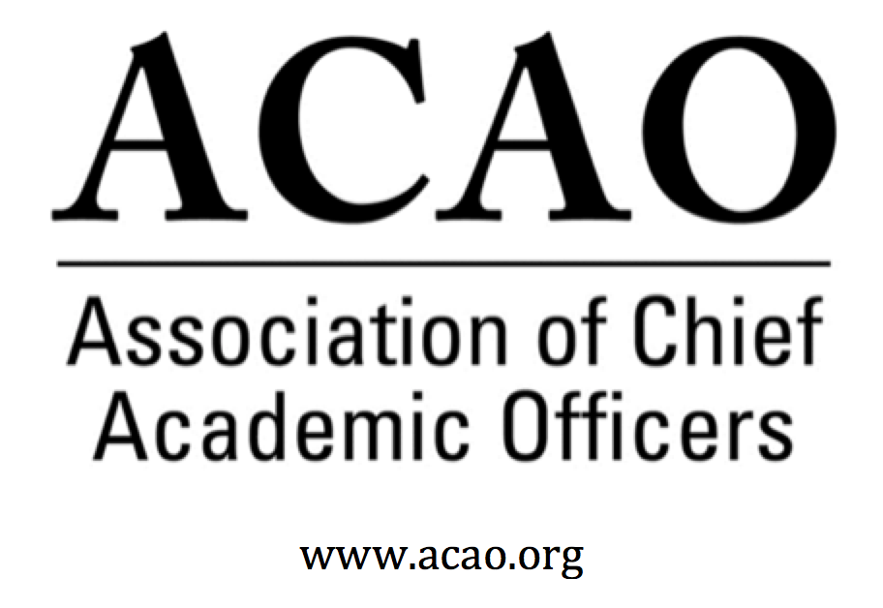

Dial: 1 408 638 0968

Meeting ID: 772 889 434

url: https://zoom.us/j/772889434

May 2, 2018
1:00pm Central/ 2:00pm ET

Attendance/Roll call:

Name | Attend | Name | Attend | Name | Attend
Martha Potvin | Y | Laura de Abruna | Y | Michaele Whelan | Y
Kathy Johnson | Y | Peter Nwosu | Y | BJ Reed | Y
Risa Palm | Y | Gregory Ochoa | Y | Rick Miranda | No
Parviz Ansari | Y | Patricia Rogers | Y | Todd Diacon | No
Mary Boyd | No | Vincent Solis | No | Kevin Carman | Y
Charles Cook | No | Connie Johnson | No | Beth Ingram | Y
Kelli Brown | Y | Sherri Hughes | No | Doreen Murner | Y
 |  |  |  | Lindy Rome (AMC) | Y

- April 4 Board Minutes – Vote to approve – M. Potvin (attached)
  - Discussion: Correct spelling for Parviz
  - Motion to accept 4-4-18 Minutes: Reed seconded. Vote: All in Favor/unanimous
- Officer Update – Martha Potvin
  - Risa Palm confirmed as Treasurer
  - Martha asked for volunteers for secretary: Kevin Carman agreed & confirmed as Secretary.
  - ACTION: Officers will be posted web update. (Doreen)
- Committee Assignments: Martha assigned all committees. ACTION – Doreen will update schedule and send to board.
- Bylaws Cmte: Individual v Institutional membership – Rick Miranda/Beth Ingram
  - Recommendation: “Individual membership is not available to existing Chief Academic Officers”. ACTION: Doreen – Comment will be added to appropriate article and section of bylaws for Individual Membership.
- Membership renewal update – Doreen Murner
  - Membership renewal letter sent 4/18th to 117 members. To date 15% renewed. Lapsed member letter sent 5/1 to 89. Prospect member letter sent 5/3rd to 195. Both lapsed and prospect letter contain membership incentive, pay now for cost of 12 months & receive 14 months (2 mos free). Next notification 6/30 will allow a grace period. A final 3-day notice will be given before termination of membership
- Records and membership
  - Martha noted that ACAO needs a better system of maintaining records regarding board membership and terms of service. ACTION: Doreen will create a legacy document.
- ACE and ACAO relationship update –
  - Martha had a conversation with Sherri Hughes to include Kathy Johnson for ACE annual meeting programming. Question posed to ACE – How can ACAO help with programs ACE offers for Chief Academic Officers. How can ACAO get increase recognition of those programs.
  - Strategic meeting with President of ACE. This is a high-level discussion on the roll of ACE and its other partners like ACAO. The Executive Committee will meet with ACE leadership (Ted Mitchell) once date is set. Sherri is working on those opportunities.
- Digital Fellows Convening Update – Laura Niesen de Abruna
  - Third convening in NOLA, completed in April with 90 in attendance. Excellent presentations. Casey Green is working on final reports for Gates Foundation and Laura will send to Doreen once completed. Once reports are complete, the Foundation will fund another $200,000. Grant still has money available to spend due to under-spent funds. Laura will be looking and working on future grants on behalf of ACAO. ACAO is branded to the convening events. Last convening is in Seattle in July.
- Advisory Council Update –
  - Ask the Provost – this program will be discussed with the Council (Sharon V) at the July board meeting. Sharon will present the concept, marketing, technology and liability of the program.
  - Recommendation of topics for next year’s Coffee Hours – When program committee asks members for ideas, the Council would like to have some of those ideas for future Coffee Hrs.
- February Financials – Martha reported $3500 in income & $37,000 in expenses. No discussion since financials represent only 2 months and its early. ACTION: Martha wants separate DF and ACAO financials v budget for July board meeting. Budget v Actuals & Budget v Prior year
- July Board Meeting in Seattle– Martha Potvin – ACTION – Doreen sent a Doodle for confirmation of board and convening attendance. Please respond. Also send Doreen your itineraries for arrival/departure dates. Doreen will work with hotel for board reservations.
- If you want ACAO communications to be sent to your admin, please make sure to send name and contact information to Doreen; office@acao.org
- New Business
  - BJ: Please use ACAO Facebook page to help keep engagement going.
  - Martha will keep working with ACE. “ACE Reimagined” - maybe an opportunity to work with ACE regional meetings.
Future Board Meetings
Jun 6, 2018 2:00 PM
July 26 - face to face meeting in Seattle
Aug 1, 2018 2:00 PM
Sep 5, 2018 2:00 PM
Oct 3, 2018 2:00 PM

